Exp: Exp2
Aaron Gomes
UID: 2025300073

Aim:
Exp :Write a program to copy 10 words (16 - bit numbers)

- From memory location 1000:0000 to 1000:2000

2)Program to modify copy paste 10 16-bit numbersFrom memory location 1000:0000 to 2000:0000

Code 1:
.MODEL SMALL
.STACK 100H

.CODE
MAIN PROC

MOV AX, 1000H
MOV DS, AX
MOV ES, AX

MOV SI, 0000H
MOV DI, 2000H

MOV CX, 000AH
CLD
REP MOVSW

MOV AH, 4CH

INT 21H

MAIN ENDP
END MAIN
OUTPUT 1: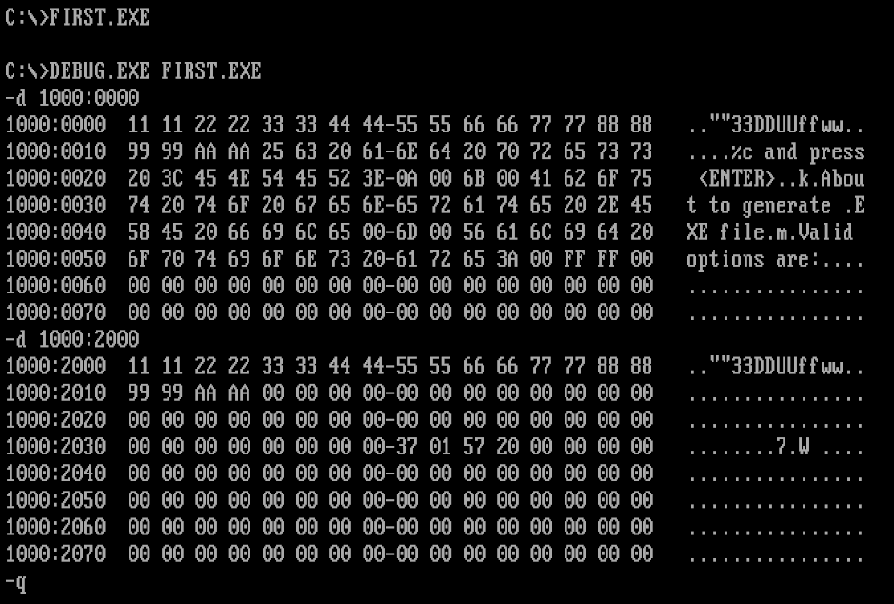

Code 2:

.model small
.stack 100h

.code
main proc

mov ax,1000h
mov ds,ax

mov ax,2000h
mov es,ax

mov si,0000h
mov di,0000h
mov cx,10

L1:
mov ax,[si]
inc ax
mov es:[di],ax
add si,2
add di,2
loop L1

mov ah,4ch
int 21h

main endp
end main

OUTPUT 2:
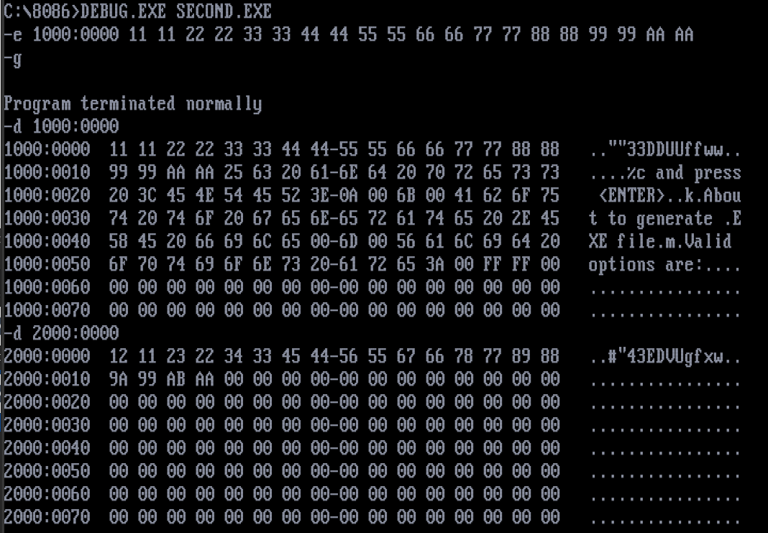

Conclusion:
10 16 - bit numbers have been successfully copied and modified ( incremented by one ) from one memory location 1000:0000 to 2000:0000.

